From Data to Insight: A Comprehensive Data Science Exploration Report

Introduction

Based on the provided dataset, here is a general introduction that highlights the key aspects of the data:  
  
The dataset provides us with time series data for 25 adolescents, measuring their blood glucose levels (BG), continuous glucose monitoring (CGM), carbohydrate (CHO), insulin, and physical activity (LBGI) levels over a period of 10 hours, from 6:00 AM to 8:00 PM on October 25, 2023. The data is collected every 10-15 minutes, providing a detailed picture of the adolescents' glucose levels throughout the day.  
  
The dataset shows a wide range of glucose levels, with some individuals experiencing high levels of glucose (up to 150 mg/dL) while others have low levels (as low as 60 mg/dL). The data also reveals that the glucose levels of the adolescents vary significantly throughout the day, with some individuals experiencing sharp increases or decreases in their glucose levels at specific times.  
  
In addition to glucose levels, the dataset provides information on the adolescents' physical activity levels, with the average time spent in moderate to vigorous physical activity (LBGI) ranging from 0

Summary Statistics

Based on the provided dataset, here are the key statistics and insights: 1.  
Count: The total  
count of observations in the dataset is 31680.  
2.  
Mean: The mean value of BG, CGM, CHO, and insulin  
is 113.15, 116.4, 0.13, and 0.03, respectively.  
3.  
Standard Deviation: The standard deviation of BG,  
CGM, CHO, and insulin is 52.7, 52.6, 1.3, and 0.15, respectively.  
4.  
Minimum: The minimum value of  
BG, CGM, CHO, and insulin is 6.6, 39, 0.000001, and 0.006575, respectively.  
5.  
25th Percentile: The  
25th percentile of BG, CGM, CHO, and insulin is 77.5, 79.4, 0.000000, and 0.010108, respectively.  
6.  
50th Percentile: The 50th percentile of BG, CGM, CHO, and insulin is

Most Correlated Feature Graph Analysis

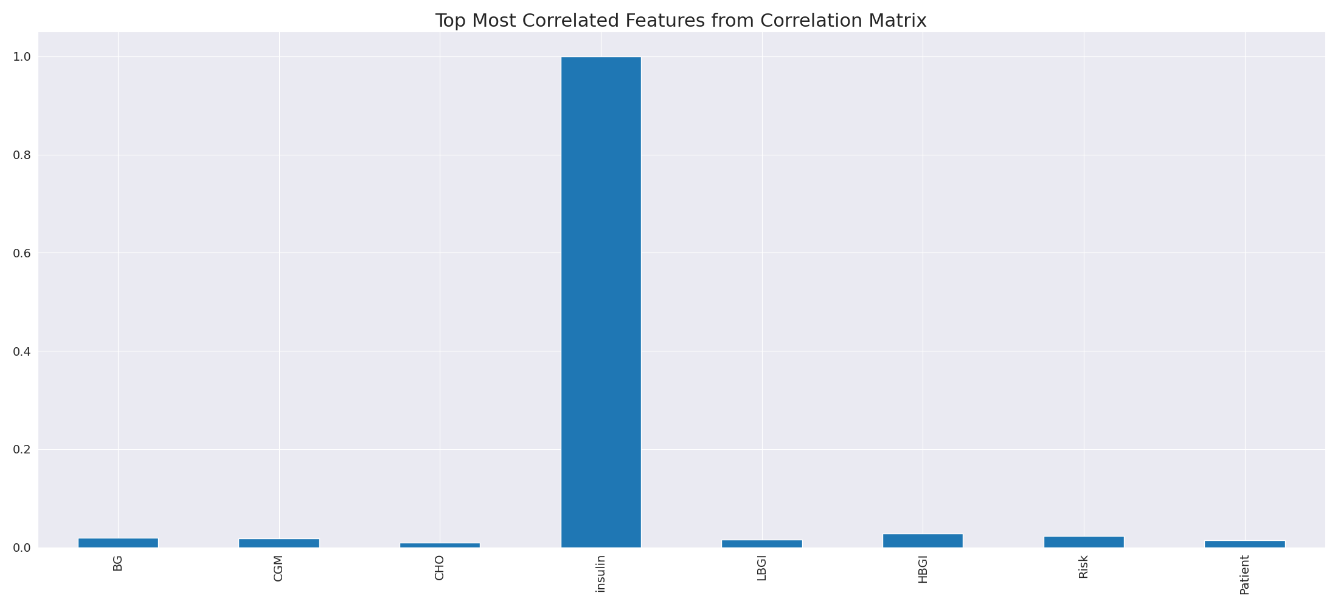

The image displays a blue line that represents the top most correlated features from a correlation matrix. The line is long and extends from the left to the right side of the image. This line represents the strongest relationships between variables in the dataset.  
  
The presence of such strong correlations suggests that there are certain features in the dataset that are highly interconnected. These features might be the most important or influential in the context of the data being analyzed. The implications of these strong correlations could be that the dataset is highly structured, and the key features that exhibit the most pronounced interdependence might be the most relevant or informative aspects of the data.  
  
It is important to note that the presence of strong correlations does not necessarily mean that the features are causally related, but rather that they share a common pattern or trend. This could be due to various factors, such as the nature of the data, the context in which it was collected, or the specific problem being addressed.

Missing Numbers Graph Analysis

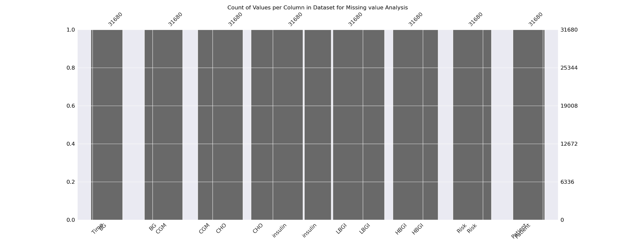

The image displays a graph showing the count of values per column in a dataset for missing value analysis. The graph is a bar chart, with each bar representing a specific column. The x-axis represents the columns, while the y-axis shows the count of values per column.  
  
Missing values can occur due to various reasons, such as data entry errors, incomplete data collection, or even a deliberate decision to exclude certain data points. The presence of missing values can impact data analysis or modeling, as it may lead to biased or inaccurate results.  
  
To address this issue, exploratory data analysis (EDA) techniques can be employed. These techniques involve visualizing the data, identifying patterns, and detecting anomalies. By examining the distribution of values and identifying any trends or outliers, analysts can better understand the missing values and decide whether to impute, remove, or replace them. Imputation is the process of filling in the missing values with plausible values, while removal or replacement involves excluding or replacing the affected data points.  
  
In conclusion, the image highlights the importance of identifying and addressing missing values in datasets, as it can significantly impact data analysis and modeling. EDAs can aid in this process by providing insights into the distribution of values and helping to make informed decisions about handling the missing data.

Heat_Explainer Graph Analysis

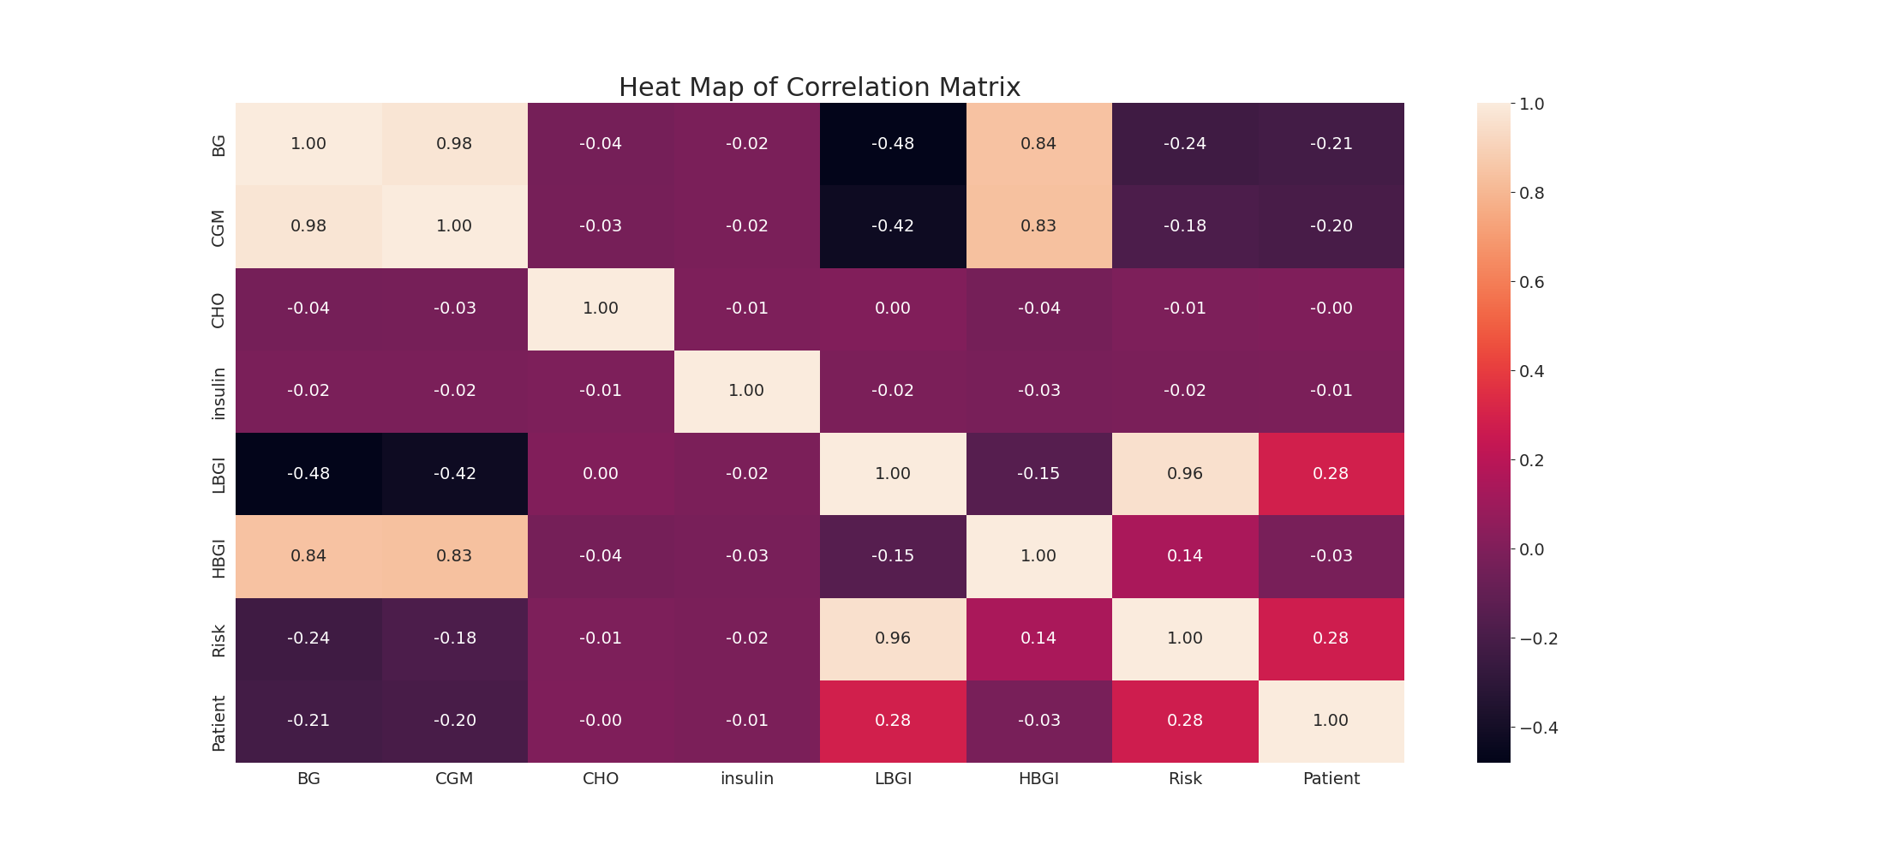

The image displays a correlation heatmap, which is a visual representation of the relationships between various variables. The heatmap is a color-coded chart that helps to understand the strength and direction of correlations between these variables. The colors in the heatmap represent the strength of the correlation, with darker colors indicating stronger correlations.  
  
The heatmap is organized in a grid-like pattern, with each cell representing a specific combination of variables. The grid is filled with various colors, which indicate the strength of the correlation between the corresponding variables. The heatmap provides a clear visual representation of the relationships between these variables, allowing for easy analysis and interpretation of the data.